Q1. How does the rating distribution differ between High protein vegetarian and high-protein non-vegetarian dishes?

Code:- **Input:-**

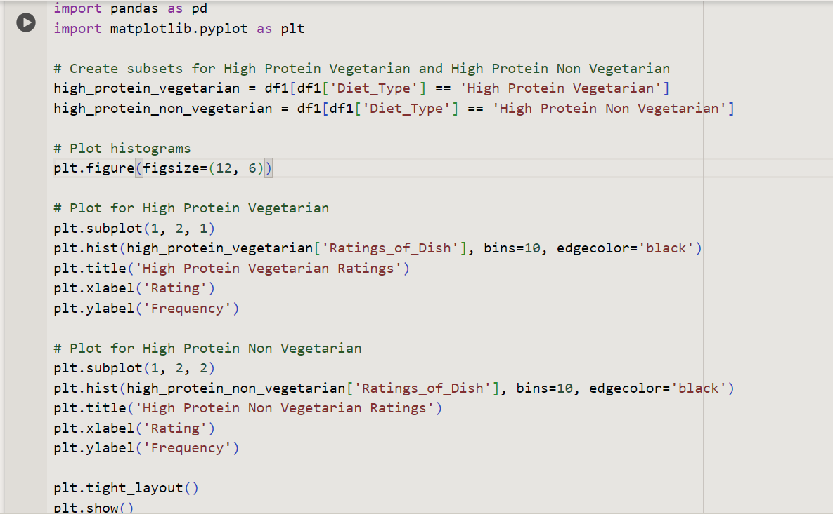

**Output:-**

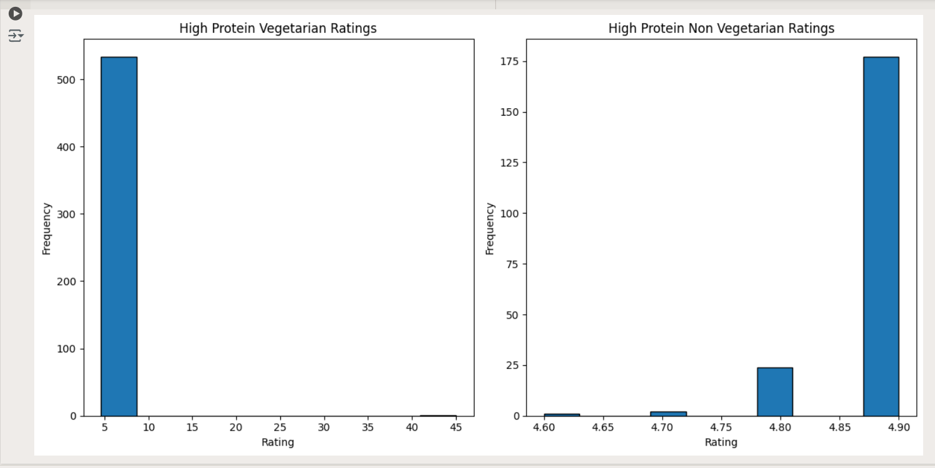

**Conclusion :-**

From the plots, you may observe whether one diet type generally has higher or more consistent ratings compared to the other. This analysis can help in understanding preferences and quality differences between high-protein vegetarian and non-vegetarian dishes.

Q2. How does dish complexity vary across Highly Rated (>4.5) Indian and International Cuisines?

Code:- **Input:-**

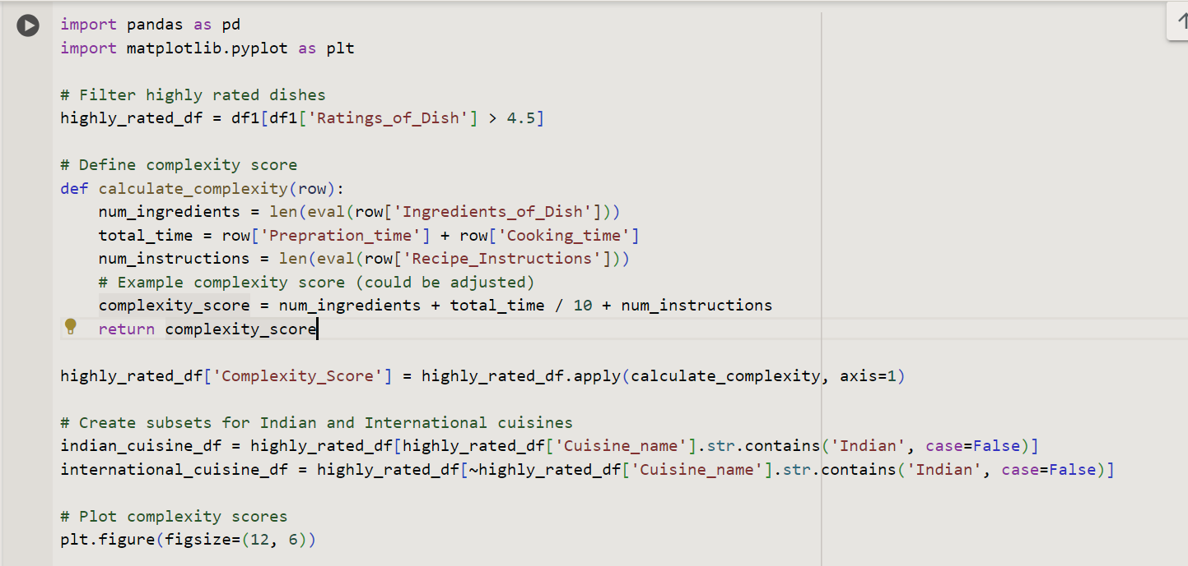

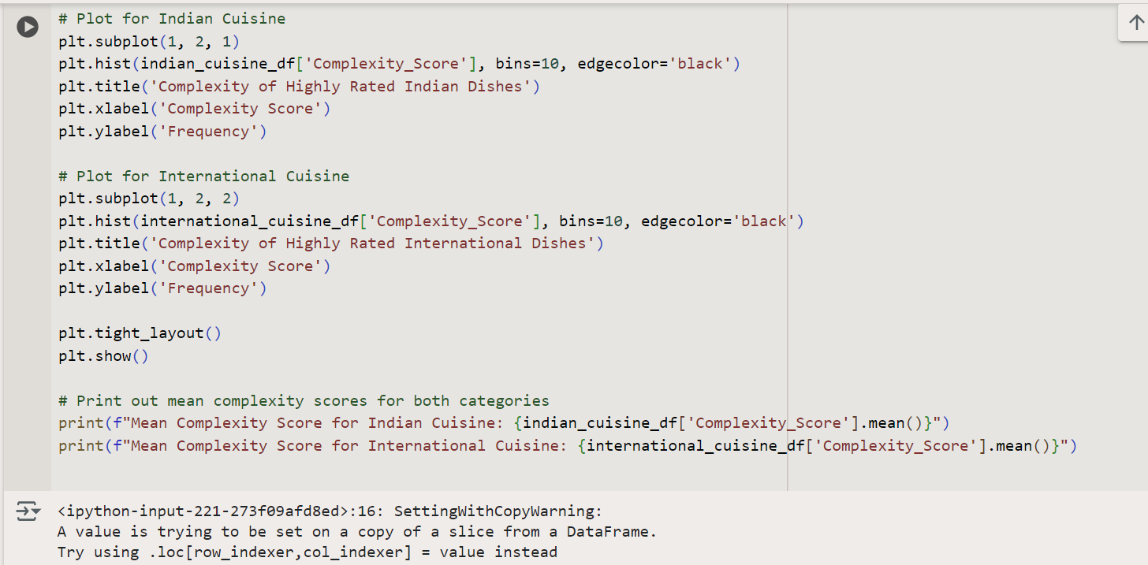

**Output:-**

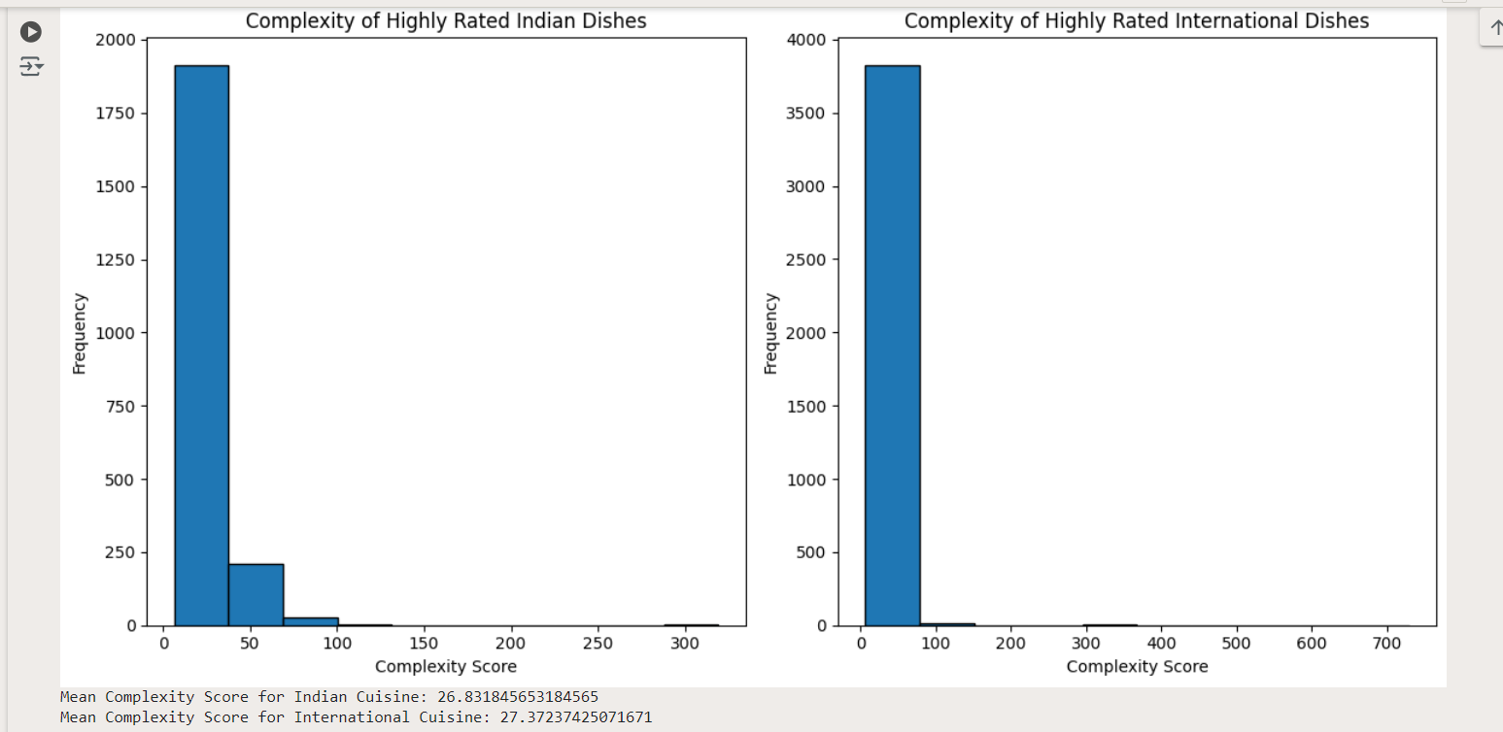

**Conclusion:-**

This analysis will help you understand whether highly-rated dishes from Indian or International cuisines tend to be more complex and how their complexity varies.

Q3. Calculate the Variation of cooking Time across various Vegetarian Diet_Types.

Code:- **Input:-**

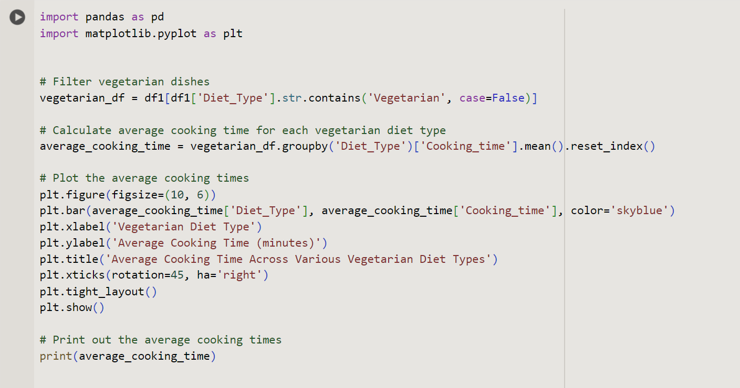

**Output:-**

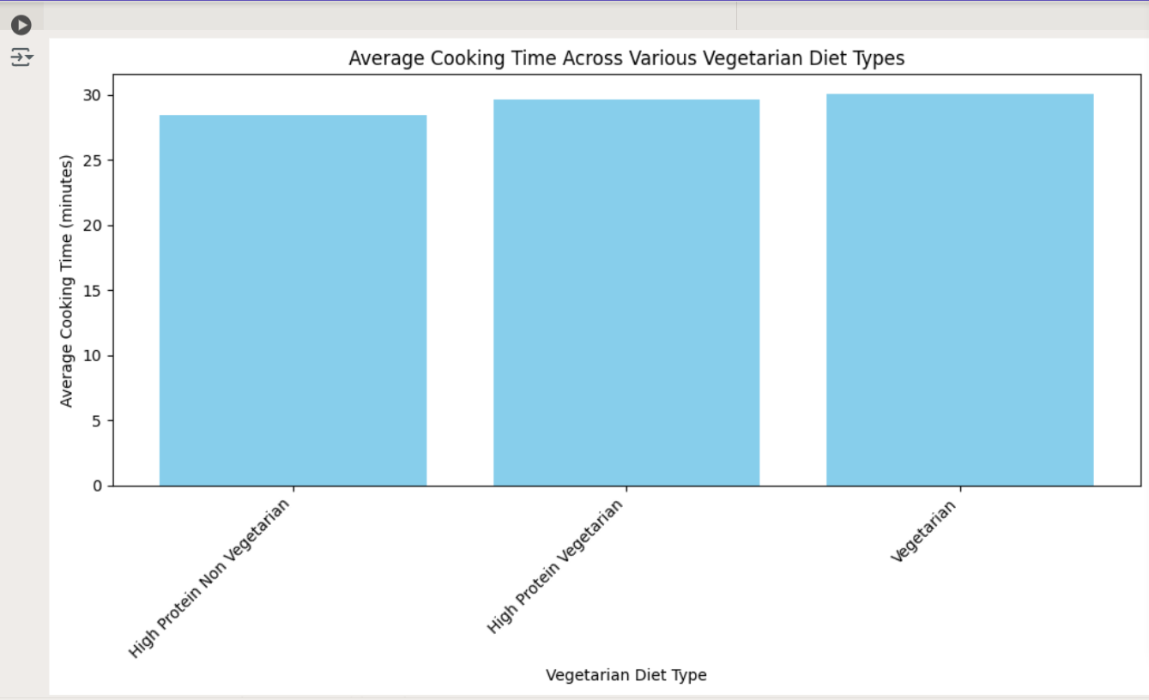

**Conclusion:**

* **Distribution Shape:** Observe the bar plot to see if any vegetarian diet types have significantly higher or lower average cooking times.
* **Comparison:** Compare the average cooking times across various vegetarian diet types to identify trends or outliers.

This will give you a clear view of how cooking times vary among different vegetarian diet types.

Q4. How many dishes are Diabetic friendly and sugar-free?

Code:-

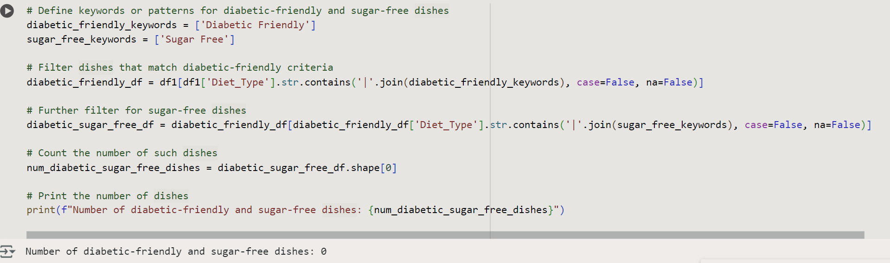

**Conclusion:-**

The number of dishes that are both diabetic-friendly and sugar-free is counted by identifying relevant keywords in the Diet_Type column, revealing how many dishes meet both criteria.

Q5. What is the most common cuisine type for each course?

Code:-

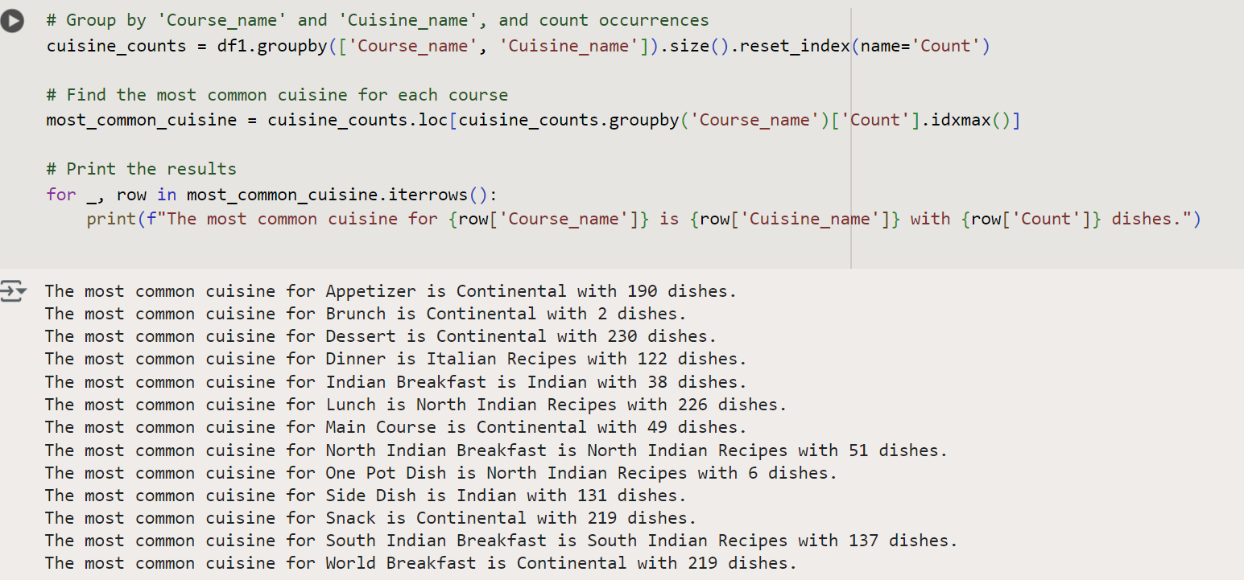

**Conclusion:-**

The most common cuisine type for each course is identified by counting the occurrences of each cuisine within each course and selecting the one with the highest frequency, providing insights into predominant cuisines per meal type.